**MODULE – 6**

# What are events in Google Analytics?

In Google Analytics, an “event” is a user interaction with a website or mobile app that is tracked separately from a pageview. Events can be used to track a wide range of actions, such as clicks on buttons, downloads of files, video plays, form submissions, and more.

Events are usually set up using JavaScript code that sends data to Google Analytics servers, including a category is used to group related events together, the action describes what the user did (e.g. clicked a button), the label provides additional information (e.g. the name of the button), and the value is a numerical value associated with the event (e.g. the price of purchase).

Events are useful for understanding user behavior beyond just page view and can provide insights into how users engage with specific elements of a website or app. They can also be used to set up conversion tracking and optimize marketing campaigns.

# Connect your created website and blog to search console, analytics, and Google tag manager and add your faculty as a user with the required permission in it.

**1) Google Analytics:-**

<https://analytics.google.com/analytics/web/#/p368070758/realtime/overview?params=_u..nav%3Dmaui>

**2) Search Console:-**

[**https://docs.google.com/spreadsheets/d/14jD8Qo0Ktxr5kGSZoy3PQOquJECmK7ZmtX9etCaYHd4/edit#gid=226462635**](https://docs.google.com/spreadsheets/d/14jD8Qo0Ktxr5kGSZoy3PQOquJECmK7ZmtX9etCaYHd4/edit#gid=226462635)

# Submit the sitemap and robot.txt file in the search console for your website.

[**..\..\https___rajkotdm.blogspot.com_-Performance-on-Search-2023-04-29.xlsx**](../../https___rajkotdm.blogspot.com_-Performance-on-Search-2023-04-29.xlsx)

# Submit the user flow and traffic source reports for your website.

<https://analytics.google.com/analytics/web/#/p368070758/reports/intelligenthome?params=_u..nav%3Dmaui%26_u..insightCards%3D%5B%7B%22question%22:%22Month-over-month%20growth%20in%20users%22%7D%5D>

# Connect your blog to Google Analytics and study the different types of traffic on your site.

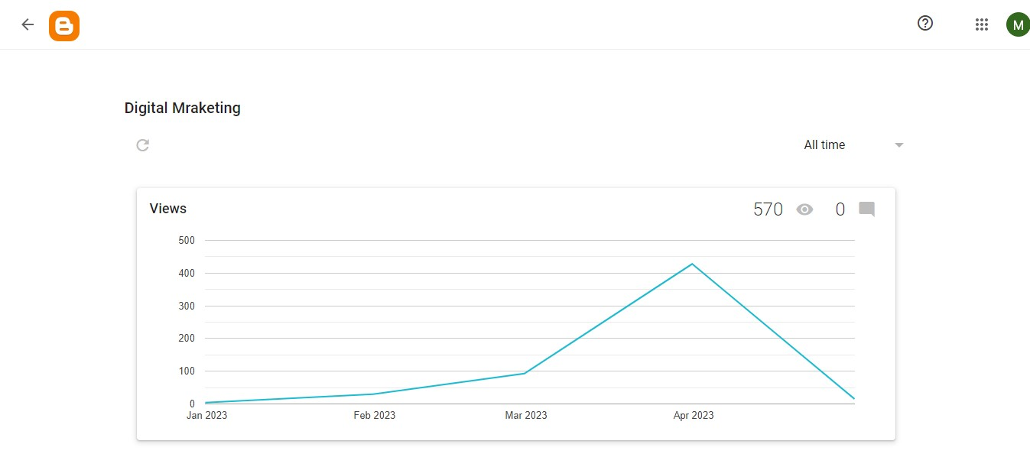

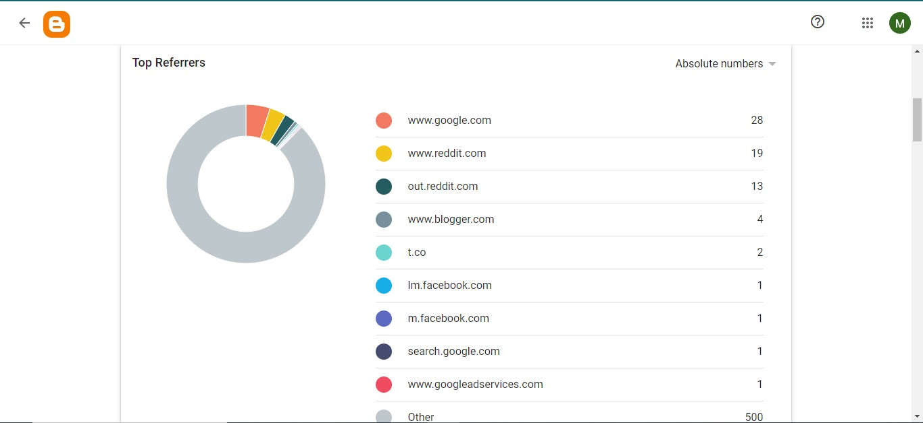

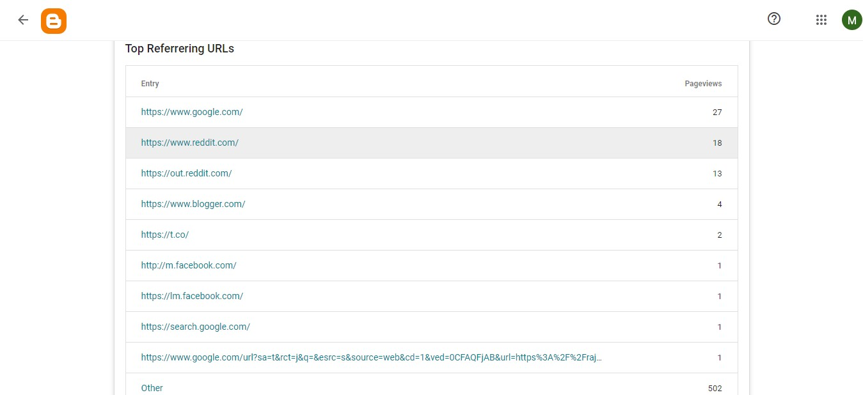

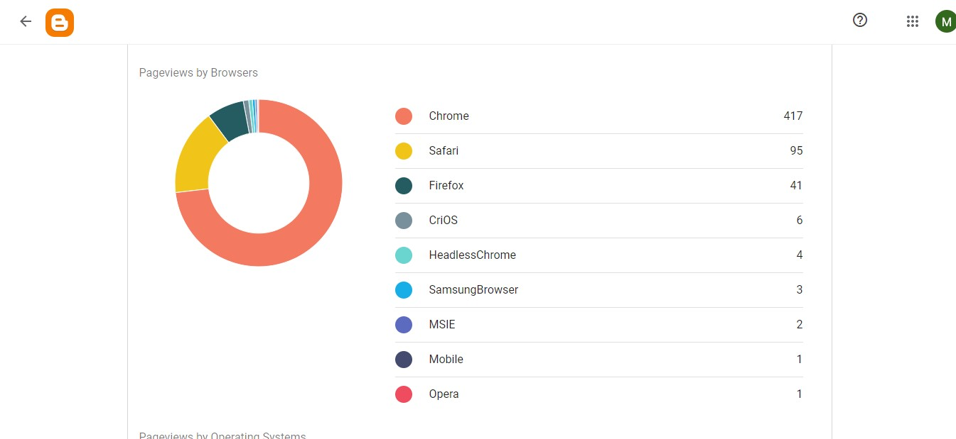

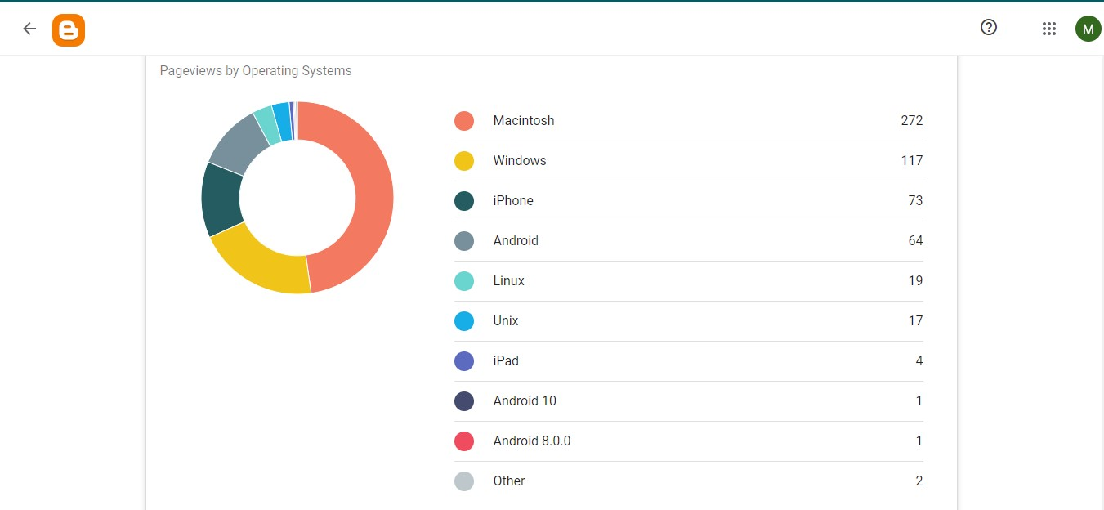

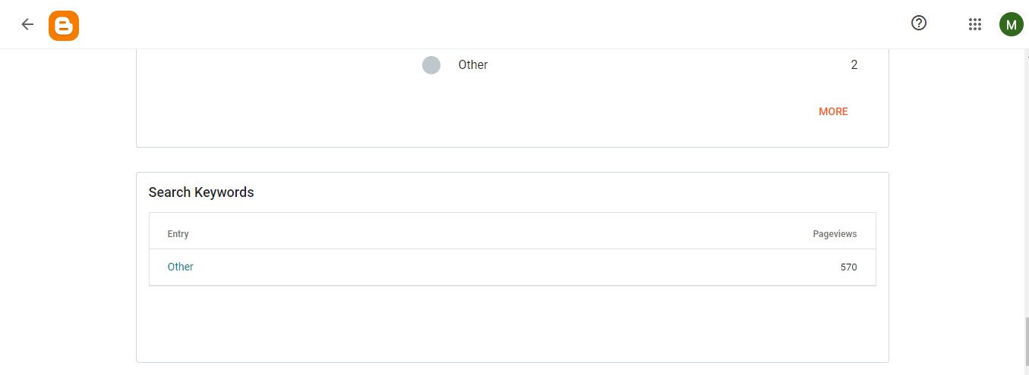

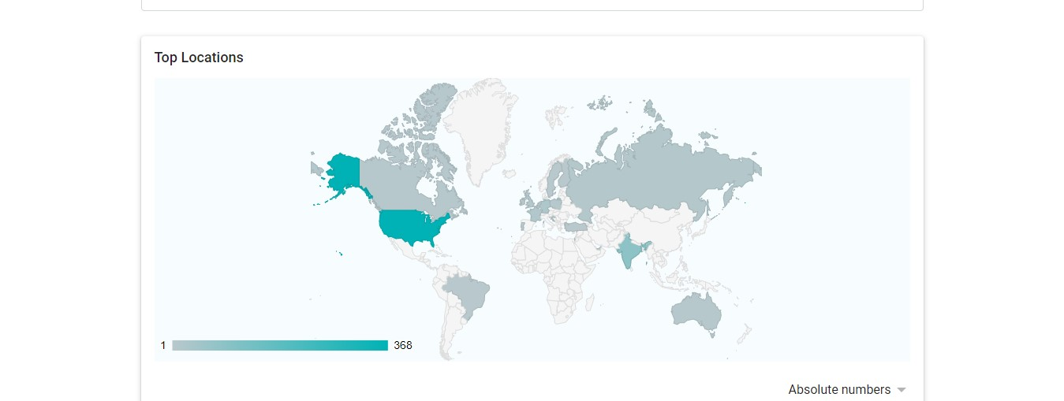

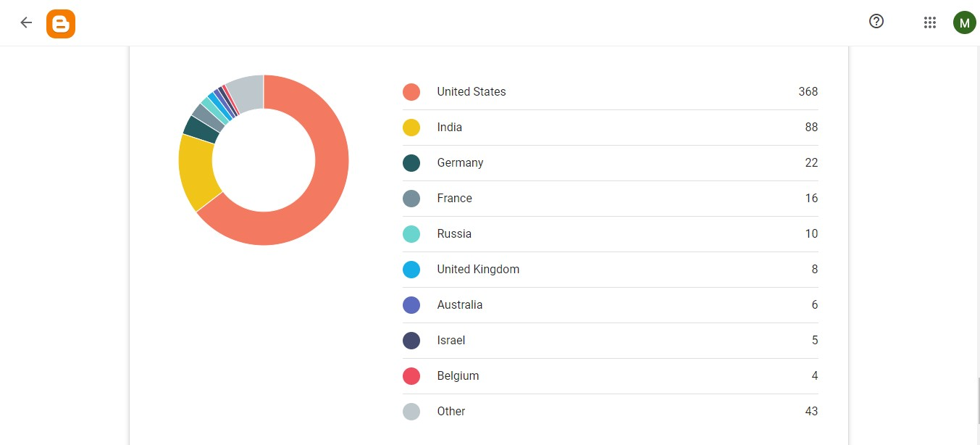

# Create a goal for your business and study reports on whether it has been completed or not.

# Track the following interaction in Google tag manager for [www.esellerhub.com](http://www.esellerhub.com)

# Link clicks

# Page load

# Time (How long a visitor stayed on a particular page)

# Button click